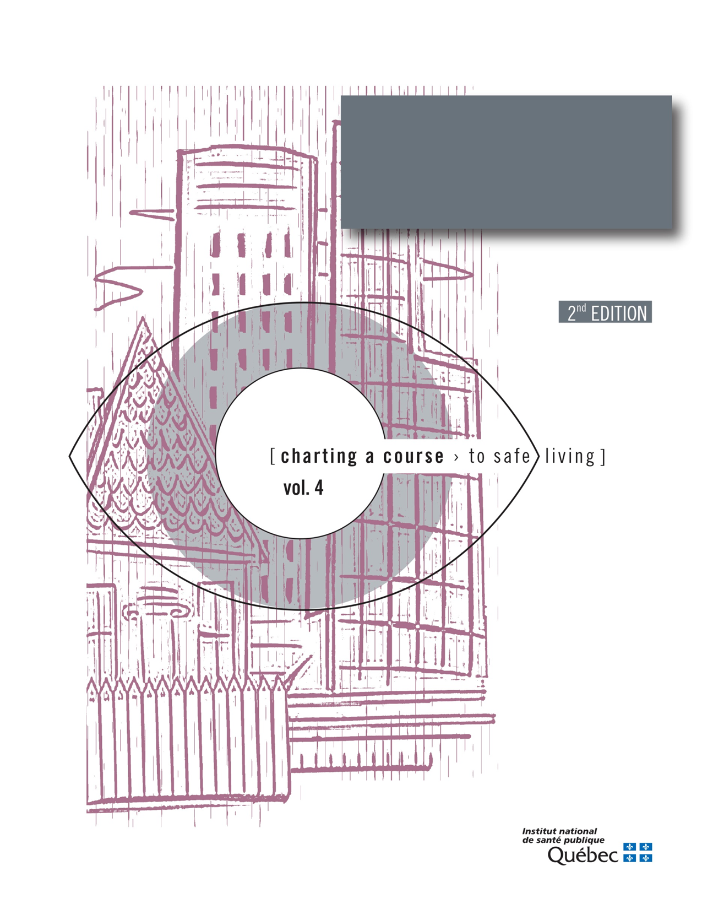

Guide to Analysing Spousal Violence withing a Region
Appendix 4
Table 8. Timetable and necessary resources
Steps | Timetable |  |  |  |  |  |  |  |  |  |  |  | Person responsible | Resources
 | J | F | M | A | M | J | J | A | S | O | N | D |  | Human | Material | Financial
Bring together individuals or groups concerned about spousal violence
Clearly define the study area
Gather information (statistics and factors)
Analyze the information and identify the key findings (statistics and factors)
Validate and supplement the information gathered (consultation with key informants)
Do the assessment
Identify the preventive interventions that need to be implemented

