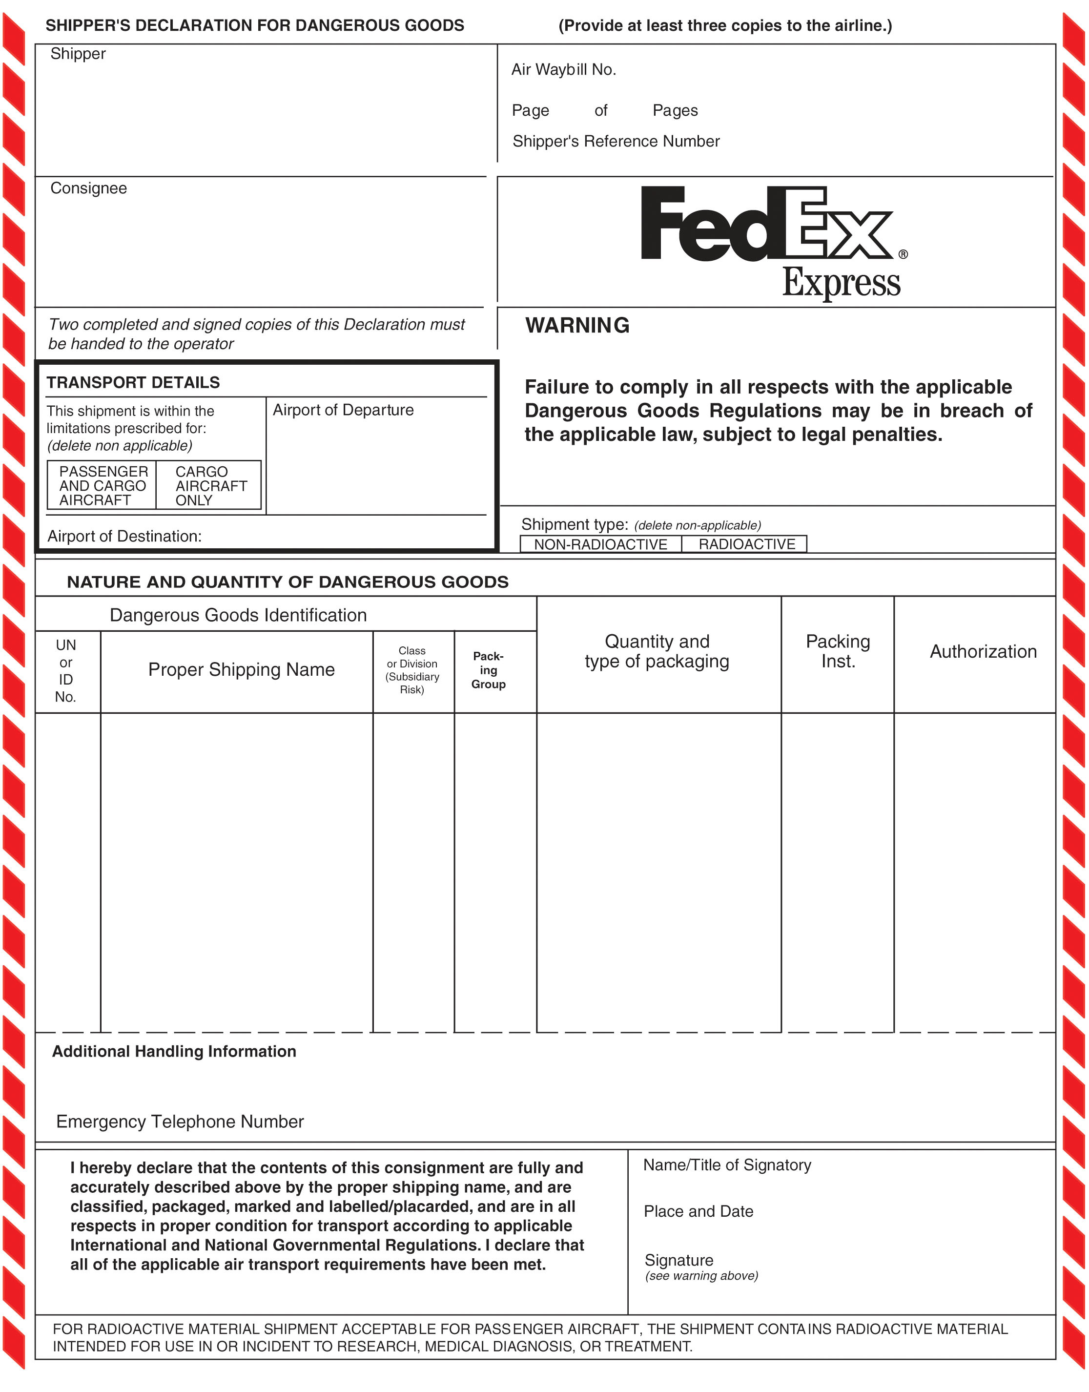
0o0 0000 0000 000
1 1

Dr David Safronetz
National Microbiology Laboratory
1015 Arlington Street, Winnipeg
MB, Canada R3E 3R2 204-789-6019

MONTREAL
XXXXXX

Winnipeg
XXXXXXX

UN Infectious substance 6.2 1 x 5 ml 620
2814 affecting humans Total: 5 mL
(Ebola virus: blood) 1 Fibreboard box

ERAP # ERP2-0746
CANUTEC 613-996-6666 ERAP Duty Officer : 1-866-262-8433

XXX / XXXX
Montreal, April 12, 2018

